108年暑期ScratchJr程式語言親子體驗營班親群組邀請QRcode及URL網址

7/20(六)三多國小
https://line.me/R/ti/g/EXMVGk3vZs
7/21(日)武林國小
https://line.me/R/ti/g/r91wdXWaMQ
7/27(六)文林國小
https://line.me/R/ti/g/sLIfHxjLQi
7/28(日)大同國小
https://line.me/R/ti/g/KKjtRHszB0
8/3(六)樹林國小
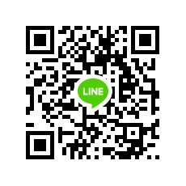 https://line.me/R/ti/g/8VAEPFHJl_
8/4(日)山佳國小
https://line.me/R/ti/g/zLtvD447o2
8/11(日)鶯歌國小
https://line.me/R/ti/g/O-L23F4gWY
8/17(六)鳳鳴國小
https://line.me/R/ti/g/MH7Mb-KTQK
8/18(日)育德國小
https://line.me/R/ti/g/IrcM87SP-Q
8/24(六)二橋國小
https://line.me/R/ti/g/IBVFZ5hpKi

