2019美國密西根MNS越南國際菁英盃競賽
2019 MNS Vietnam International Elite Cup Competition, Michigan, USA
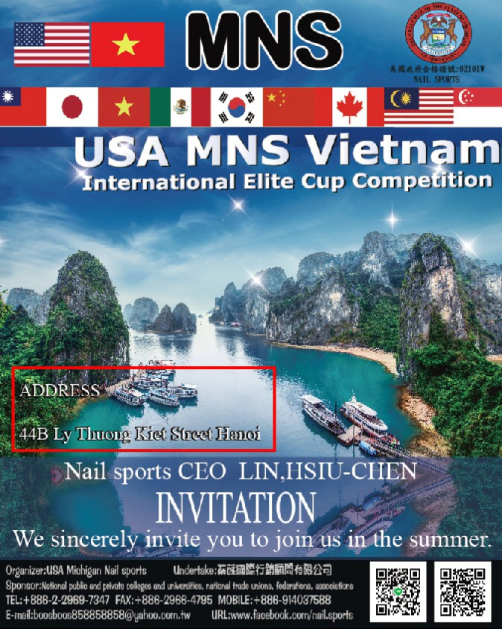
壹、比賽概述:
一. 競賽名稱：2019 美國密西根MNS越南國際菁英盃競賽.
二. 參與競賽國家：越南、馬來西亞、臺灣、泰國、日本、香港、新加坡、中國…等，預計參賽人數為300名(境外參賽者名額70名)。
三. 台灣參與對象說明:全國各高中職暨大專院校教師以及在學學生（含研究生與外籍生），不限科系與年級皆可報名參加。
四. 出團日期：2019年7月24~28日共5天。
A, competition overview:
1. Competition Name: 2019 MNS Vietnam International Elite Cup Competition, Michigan, USA.
2.Participation in the competition countries: Vietnam, Malaysia, Taiwan, Thailand, Japan, Hong Kong, Singapore, China, etc., the number of participants is expected to be 300 (70 overseas contestants).
3. Description of participants in Taiwan: All high school and post-secondary college teachers and students (including graduate students and foreign students), regardless of the department and grade level, can register.
4. The date of departure: 5 days from July 24 to 28, 2019.

7月24 | 抵達越南大會研習會  Arrived at the Vietnam Conference Seminar
7月25 | 大會國際技術交流會 / 賽場設備說明  Conference International Technical Exchange / Stadium Equipment Description
7月26 | 大會賽前國際評審會議 /  2019 美國密西根MNS越南國際菁英盃競賽淘汰賽  Pre-match international review meeting /  2019 MNS Vietnam International Elite Cup Competition Elimination Competition, Michigan, USA
7月27 | 2019 美國密西根MNS越南國際菁英盃競賽決賽  2019 MNS Vietnam International Elite Cup Competition Finals, Michigan, USA
7月28 | 回程台灣  Return to Taiwan
五、競賽日期：為7月25~27日。
六、團費: NT $ 35,000元台幣（包括來回機票及5天、國際星級館住宿費、飲食費、越南簽證費和機場巴士接送）。

5. Competition date: July 25~27.
6. Group fee: NT$35,000 (including round-trip airfare and 5 days, international star hall accommodation, food and beverage, Vietnamese visa fee and airport bus transfer).
1. 若須延後回台，務必事先告知，機票處理費須由搭乘者自行支付。
2. 除機場來回巴士接送，比賽外的時間，可統一行動參訪相關業者。
3. 每一項比賽報名費為學生組:US $150美金、社會組US $250美金、名師名店US $500美金（須額外支付），每人最多報名三項，請洽本會繳費。
4. 國際評審註冊費NT $5,000元台幣（須額外支付，另擔任評審須傳履歷經大會審核通過。大會另聘英語或越語通譯）。
5. 各國參賽者及評審，均會登錄於現場大賽英文手冊。

1. If you need to delay the return to Taiwan, you must inform in advance that the ticket processing fee must be paid by the passenger.
2. In addition to the round-trip bus transfer from the airport, the time outside the competition can be unified to participate in the relevant operators.
3. The registration fee for each competition is for the student group: US$150 USD, US$250 for the social group, US$500 for the designer's name store (extra charge), and up to three for each person. Please contact us for payment.
4. The international review registration fee is NT$5,000 (subject to additional payment, and the review must be reviewed and approved by the conference. The conference is also available in English or Vietnamese).
5. National contestants and judges will be registered in the English manual of the on-site contest.
七、競賽地點：44B Ly Thuong Kiet Street Hanoi Vietnam。
7. Venue: 44B Ly Thuong Kiet Street Hanoi Vietnam.
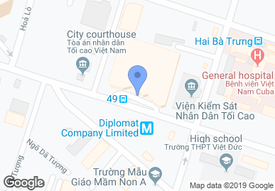
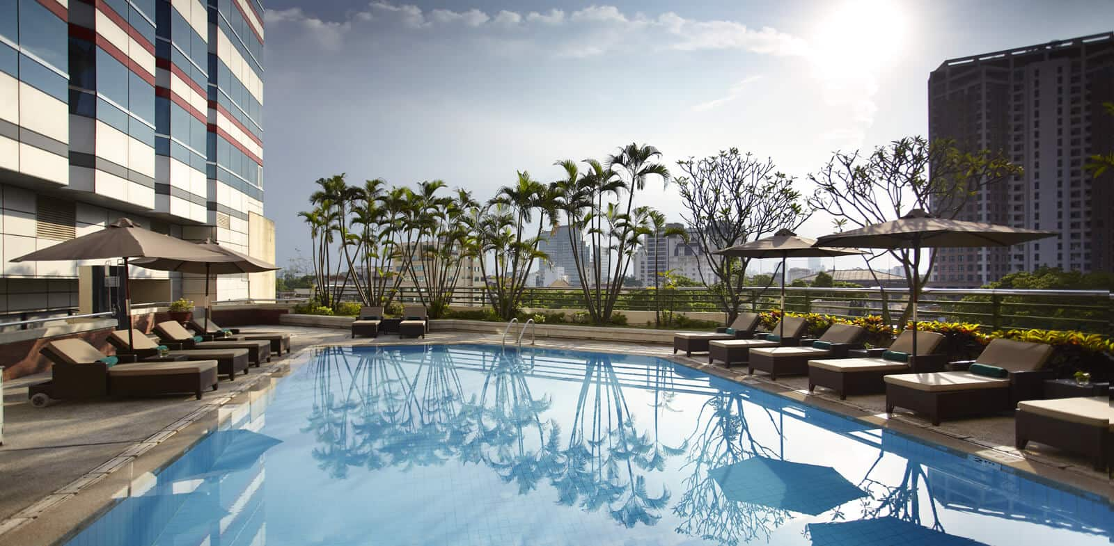
八、主辦單位:美國密西根MNS國際技能認證中心(美國政府合格證號02101W).
boosboos858858858@gmail.com
九、協辦單位：Jonny Walker越南總代理公司、法國Agnese & Charles cellar。
8. Organizer: MNS International Skills Certification Center of the United States (US Government Certificate No. 02101W).
Boosboos858858858@gmail.com
9.Nine, co-organizer: Jonny Walker Vietnam distributor, France Agnese & Charles cellar.
十、競賽項目：E 酒類比賽
E5 葡萄酒侍酒服勤.
E5-1 葡萄酒品評技能.
E5-2 創意調飲傳統調酒.
E5-3 創意調飲花式調酒.
10. Competition: E Liquor Competition
E5 wine serving service.
E5-1 Wine Tasting Skills.
E5-2 Creative brewing traditional bartending.
E5-3 Creative brewing fancy bartending.
十一、注意事項: 11, note:
(一) 凡是於2019年獲得下列賽事排名:
(a) The following rankings were awarded in 2019:
A.曾參加4/20密西根MNS競賽
B.曾參加4/26首彩盃澳洲葡萄酒盲飲賽.
C.曾參加5/24萊茵盃德國葡萄酒盲飲
A. Has participated in the 4/20 Michigan MNS competition
B. Has participated in the 4/26 first color cup Australian wine blind drinking contest.
C. Participated in the 5/24 Rheinland German wine blind drink
1.冠軍之越南賽補助金:5000元.
2.亞軍之越南賽補助金:4000元.
3.季軍之越南賽補助金:3000元.
4.第四名/第五名-越南賽補助金:1000元.
5.優勝金口/佳作銀口-越南賽補助金:500元.
1. The winner of the Vietnam Championship: 5000 yuan.
2. The runner-up Vietnam tournament subsidy: 4000 yuan.
3. Third place Vietnam tournament subsidy: 3000 yuan.
4. Fourth place / fifth place - Vietnam match grant: 1,000 yuan.
5. Winning Jinkou / Jiazuo Yinkou - Vietnam Safari: 500 yuan.
(二)參賽者請預先詳讀比賽規則，報名後所有參賽者，已視同同意大會一切比賽規則。
(三)參賽者於確認報名手續完成後，將由大會現場發予通行證，參賽者與工作人員皆憑證入場。
(四)參賽選手皆需著專業服裝（男性西裝、女性套裝），及所有材料均需自行準備。
(2) Participants are requested to read the rules of the competition in advance. All participants after the registration have agreed to agree to the rules of the competition.
(3) After confirming the completion of the registration procedures, the entrants will be issued a pass to the venue, and the entrants and staff members will be admitted to the venue.
(4) All contestants are required to wear professional clothing (male suits, women's suits), and all materials must be prepared by
十二、報名方式:
統一採取線上報名，請參考本簡章末頁說明。
12. Twelve, registration method:
For online registration, please refer to the description on the last page of this brochure.

貳、競賽規則2.competition rules
- 各比賽項目之作品，僅適用於該項目之評分。
- 已完成報名之比賽項目，不得更改及缺席，否則視同放棄比賽資格，恕不提供退費。
- 比賽會場於早上09:30開放，參賽者請勿擅自移動展區內的展品，下午16點後方可開始撤收，若17點後尚未撤除展品，大會保有清除的權利。比賽結束後，垃圾需集中處理於垃圾區內。
- 大會人員在比賽時有權要求拍攝參展品及使用宣傳其產品照。
- 獲獎參賽者或其代表，請攜帶校系旗，並請穿著正式專業服裝或各校衣服出席頒獎典禮。
1. The works of each competition item are only applicable to the rating of the project.
2. The contested project has not been changed and absent. Otherwise, it will be deemed as a waiver of the competition and no refund will be provided.
3. The competition venue will be open at 09:30 in the morning. Participants are not allowed to move the exhibits in the exhibition area. The collection can be started after 6:00 pm. If the exhibits have not been removed after 17:00, the conference reserves the right to clear. After the game is over, the garbage needs to be concentrated in the garbage area.
4. The members of the conference have the right to request to shoot the exhibits and use the promotional photos of the products during the competition.
5. For the winners or their representatives, please bring the school flag and wear formal professional clothing or school clothes to attend the awards ceremony.
- 大會不負責任何參展品、設備器具或私人物品的保管及損害賠償。
- 如有不可抗拒之因素，或為使賽事順利進行之情況，大會保有修改、增加或刪除規則之權利。
- 參賽者需謹遵評分判決，大會不接受任何對共識成績之主觀意識差異的申訴。
- 報名資料未填寫完整者不予接受報名，僅採用E-mail寄送護照及選手照片，不接受紙本郵寄、圖片檔或PDF…等非標準形式之報名。
- 如果有展示作品簡介及創作理念，宜同時具備英文說明以利國際評審評分。
6. The General Assembly is not responsible for the custody and damages of any exhibits, equipment, or personal belongings.
7. The General Assembly reserves the right to modify, add or delete rules in the event of irresistible factors or in order to facilitate the event.
8. Participants are required to follow the scoring judgment and the General Assembly does not accept any complaints about the difference in subjective awareness of the consensus results.
9. If the registration information is not completed, the registration will not be accepted. Only the E-mail will be used to send the passport and the photos of the players. Registration in non-standard forms such as paper mail, photo files or PDF will not be accepted.
10. If you have a brief introduction and creative concept, you should also have an English description to benefit the international review score.
- 獲勝之選手個人可分別得到金、銀、銅獎，未達得獎分數者不予授獎。
- 本規則請於報名前詳閱，報名後視同同意本賽事規則。
11. Winning players can receive gold, silver and bronze prizes respectively, and those who do not reach the prizes will not be awarded.
12. Please read the rules carefully before registration. After registration, you will agree to the rules of this competition.
參、比賽細項及規範3 Participation, competition details and specifications.
（3一）酒類專業競賽Drink category International competition:
E5葡萄酒侍酒服勤  E5 wine serving service | 1.開放可使用中、英、法文應試。  2.請穿著侍酒師(服務生)正式服裝參與競賽。  3.賽事以實際侍酒操演方式進行，(學生組參賽者有9分鐘完成相關要求動作)，(社會人士組參賽者有8分鐘完成相關要求動作)。  4.比賽內容包括：  A.紅葡萄酒侍酒服務包含：開瓶、選酒杯、醒酒、換瓶、侍酒服務、侍酒禮儀…等。  B.禮貌與儀態：為男女賓客服勤期間之衛生安全動作、葡萄酒服勤禮儀與人員儀態笑容。  5.選手須自備器具:標準侍酒刀、廚房紙巾2張、簡易打火機、白色服務巾乙條。  大會準備器具:各款酒杯、醒酒器、IBM(45cmX180cm)服務桌、………等。  6.使用酒款:軟木塞型葡萄酒。  1. Open to use Chinese, English and French exams.  2. Please wear a formal costume of a sommelier (waiter) to participate in the competition.  3. The competition is conducted in the actual manner of serving alcohol. (The student group participants have 9 minutes to complete the relevant required actions), (the social group participants have 8 minutes to complete the relevant requirements).  4. The content of the competition includes:  A. Red wine serving services include: opening bottles, selecting wine glasses, sobering, changing bottles, serving wine, serving wine etiquette...etc.  B. Courtesy and manners: for the safety and security movements of the male and female guests during the service, wine service etiquette and personnel smile.  5. Players must bring their own equipment: standard sommelier, kitchen paper towel 2, simple lighter, white service towel.  Assembly preparation equipment: various wine glasses, decanter, IBM (45cmX180cm) service table, .........etc.  6. Use of wine: cork wine.
E5-1葡萄酒品評技能 | 競賽內容：葡萄國際品種酒款。  器具：每人１紅酒杯／１白酒杯／１水杯／每１人一個吐酒紙杯。  其中挑選出１款紅葡萄酒與１款白葡萄酒進行品評 (Deductive tasting)。  評分標準：白酒品評勾選題50%、紅酒品評勾選題50%.  Contest content: Grape international variety wine.  Appliances: 1 red wine per person / 1 white wine glass / 1 water glass / 1 wine glass per person.  One red wine and one white wine were selected for deductive tasting.  Grading criteria: 50% of the white wine tasting and 50% of the wine tasting.
E5-2創意調飲傳統調酒 | 一、(1) 主辦單位提供：冷水、熱水、冰塊、小冰桶、廢水桶、垃圾桶、工作檯、作品展檯。  (2)其餘材料及器具（如:冰夾、裝飾物、咖啡、基酒、酒類、糖漿、果汁、吧叉匙、量杯、果汁機、競賽成果展示杯具），則由選手自備。  二、主辦單位將發行得獎作品配方，入選者須配合拍照及相關製作文字說明等。以指定酒至少1oz自行創意調製作品(大會得播放統一音樂)，選手呈現2大杯相同容量(長短飲不限)，1杯展示1杯評審試飲。  三、曾參加其他相關活動之酒譜、作品者不得重複使用參賽，倘遭主辦單位發現，將撤銷資格並追回獎狀。智慧財產權等相關法律責任須由參賽者自負。  四、參賽者在展檯上附上中英飲品解說卡，提供食材或創意發想之必要說明，以增強飲品價值，爭取評審之認同。參賽者需於競賽結束後協助清理現場環境，工作人員確認後方可離場。  五、所有原物料進場前，須經評審檢查驗證，與書審資料相符，並不得使用危害人體健康的食材飲料。  1. (1) The organizer provides: cold water, hot water, ice cubes, small ice buckets, waste water buckets, garbage bins, work platforms, and exhibition booths.  (2) The rest of the materials and utensils (such as: ice clips, decorations, coffee, base wine, alcohol, syrup, juice, bar forks, measuring cups, juice machines, competition results display cups), the players themselves.  2. The organizer will issue the formula of the winning work, and the selected person must cooperate with the photo and related text descriptions. The creative is made with at least 1 oz of the designated wine (the conference has to play unified music), the player presents 2 cups of the same capacity (long and short drinks are not limited), 1 cup shows 1 cup of review tasting.  3. Those who have participated in other related activities, such as wine scores and works, may not re-use the competition. If found by the organizer, they will be disqualified and recover the certificate. The relevant legal responsibilities of intellectual property rights shall be borne by the entrant.  4. Participants will attach a Sino-British Drinks Interpretation Card to the booth to provide the necessary instructions for the ingredients or creative ideas to enhance the value of the drinks and seek recognition from the judges. Participants are required to assist in cleaning up the site environment after the competition is over, and the staff can confirm the departure before leaving the venue.  5. All raw materials must be verified by inspection and verification before entering the site, which is consistent with the materials of the book review, and shall not use food and beverages that are harmful to human health.  六、競賽食材儘量以現場製作為佳，嚴禁攜帶不明材料進入競賽場地，展檯桌面展示擺盤之裝飾品則不在此限。  七、當日參賽選手若有任何成績疑問，評審委員有最後絕對裁決權。  八、主辦單位概不負責保管競賽隊伍所攜帶之器具與個人之財物。  九、參賽選手須與繳交報名表/製作材料及步驟表相同，不得更換，違反者以棄權論。  十、請選手穿著自備專業調飲服裝參賽。  十一、每位參賽者有5分鐘完成相關要求動作。  十二、參賽者未以指定基酒參賽(公布於官網)，將不列入前三名。  6, the competition ingredients should be made on the spot as much as possible. It is strictly forbidden to bring unidentified materials into the competition venue. The decorations on the table top display are not limited.  7. If the contestant has any questions on the day, the jury member has the final absolute decision.  8. The organizer shall not be responsible for the custody of the equipment and personal belongings carried by the competition team.  9. The contestants must be the same as the application form/production materials and schedules, and must not be replaced.  10. Players are required to wear their own professional drinking and drinking costumes.  11. Each contestant has 5 minutes to complete the required action.  12. Participants who do not participate in the designated base wine (published on the official website) will not be included in the top three.  評分標準：  - 成品整體:名稱、裝飾物、具整體概念、整體創意與造型等。  - 口感: 材料、配方、份量、風味。  - 專業技術: 專業知識、態度、儀態、服儀、調配技術、飲料成分、調製步驟、整潔與秩序感、整體時間。  - 逾時扣分方式：逾時第5秒起每秒扣1分。若逾時逹100秒，將直接請選手下台，總成績以零分計算。  Grading:  1. The whole product: name, decoration, overall concept, overall creativity and modeling.  2. Taste: Material, formula, serving size, flavor.  3. Professional skills: professional knowledge, attitude, manners, service, blending techniques, beverage ingredients, modulation steps, cleanliness and order, overall time.  4. Time-out deduction method: 1 point deducted per second from the 5th time of the timeout. If the timeout is 100 seconds, the player will be directly dismissed, and the total score will be calculated as zero.
E5-3創意調飲花式調酒

獎項及內容區分  Awards and content distinction | 總分  Total score | 頒發  Issued
金牌gold medal | 100分~91分  100 points to 91 points | 獎牌證書  Medal certificate
銀牌silver medal | 90分~81分  90 points to 81 points | 獎牌證書  Medal certificate
銅牌bronze medal | 80分~71分  80 points to 71 points | 獎牌證書  Medal certificate
未達70分一律不發獎牌及證書
No medals and certificates will be issued if the score is less than 70 points
報名方式
**每名參賽者可一項或多項報名個人最多三項報名**
（評審與選手資格不得重覆）
E 酒類比賽
E5 葡萄酒侍酒服勤.
E5-1 葡萄酒品評技能.
E5-2 創意調飲傳統調酒.
E5-3 創意調飲花式調酒.
ways of registration
**Each entrant can register up to three entries for one or more applicants**
(Review and player qualifications must not be repeated)
E Alcohol competition
E5 wine serving service.
E5-1 Wine Tasting Skills.
E5-2 Creative brewing traditional bartending.
E5-3 Creative brewing fancy bartending.
1. 統一採取線上報名 https://x.co/6njTu
2. 完成線上報名後請將下列資料寄至escort1214@gmail.com承辦窗口李小姐電子郵件（1）護照資料頁照片/掃描（2）個人專業半身照（男生黑西裝皮鞋、女生黑套裝皮鞋）。
3. 報名期間:即日起至報名額滿為止，額滿即不再受理。
4. 因不可抗拒之原因，本會有權更改本次活動感謝配合。
（機票:由於團體訂購機票，如已完成開票後將無法再退機票費用）
1. Unified online registration https://x.co/6njTu
2. After completing the online registration, please send the following information to escort1214@gmail.com to undertake the window Miss Li email (1) Passport information page photo / scan (2) Personal professional half-length photos (boys black suit shoes, girls black suit shoes) .
3. Registration period: From now until the full amount of registration, the amount will not be accepted.
4. Due to irresistible reasons, this club has the right to change the event to thank you for your cooperation.
(Airfare: Due to the group booking ticket, if the ticket has been completed, the ticket will not be refunded)

