2019業勤暑假前期末退鑰匙注意事項-英文版
Key Refund Precautions-English version
地點(Room No) :5133
時間(Time): 請配合以下時段 please cooperate to do at
  - 6/21 Pm 19:00~21:00
  - 6/22 am 10:00~12:00、pm 15:00~17:00、
Pm 19:00~21:00
  - 6/23 am 10:00~12:00、pm 15:00~17:00
- Please took your key to the final roommate who will be the last one to leave dormitory. When the last one of each room prepare to leave, please send a message to each floor Line group one hour before or the last night before your departure. Please check all by yourself about cleaning of environment, bed, closet door open, drawer open 1/3, then upload the photos to Line group, the ask the floor leaders come to check and signature on the bedroom checklist. Then take your key to 5133. If your cleaning is not meet the requirements, the key deposit will not be refunded.
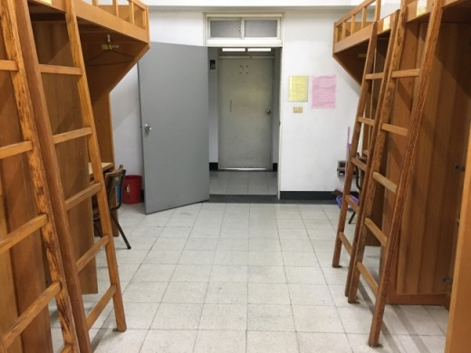
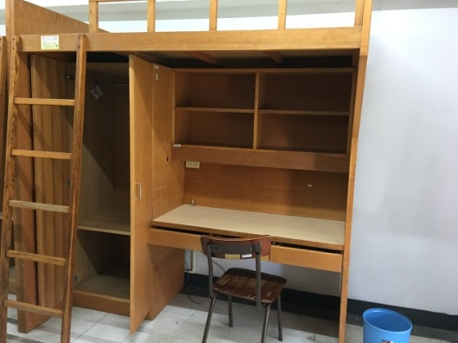

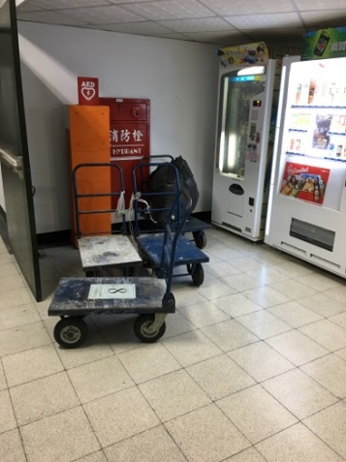
- All other type of trashes should be taken to the dumpster outside the dormitory in accordance with the dormitory waste classification policy.
- After you are finished using hand-drawn carts, please return them to the first floor in situ. Don’t place carts in your room, nor take them away from the dormitory.
- Items such as washbasin, quilts, pillows, mattresses, hangers etc. should be brought into the study classroom on the 1st floor. Don’t discard those types of items into the dumpster outside the dormitory.
